*Skin Disease Detection App*

Karuna Rani  
AIML *(of Affiliation)*  
Chandigarh University *(of Affiliation)* Chandigarh, India

karunagulati0@gmail.com

**Abstract**

***Skin is one of the most important and sensitive organs of our human body. It is the first protective layer of our body. The skin may get infected, damaged due to various environmental conditions, eating habits and due to improper care. Nearly 40-50% of people all over the world are suffering from skin diseases. Skin is the largest organ and the unavailability of proper care for infected skin may lead to an abnormal lifestyle*[1]*. People living in rural areas have a low chance of detecting the disease and getting it cured on time.***

***We have developed an app to detect skin diseases with the help of Image Classification using the teachable machine. We have trained and tested our app on seven skin conditions***

***named 1. Healthy Skin 2 Blisters. 3. Acne 4. Chickenpox 5. Eczema 6. Melanoma 7. Psoriasis***

***Keywords— Machine Learning, Skin Disease, Teachable Machine***

# **Introduction**

Skin is the most exposed organ to foreign particles. Skin Diseases are more common and cause stress to patients[1]. In most cases, skin disease is caused by fungal infection, bacteria, allergies and viruses. Skin disease may spread quickly and lead to an abnormal lifestyle if not cured within a time period. Early detection and cure are important for patients as they may face skin damage, skin cancer over a period of time. Factors like economic conditions, illiteracy, lack of knowledge, access to doctors, awareness of skin-related diseases are the most common issues.

People suffering from skin diseases find it difficult to handle physical, emotional stress which leads to issues like emotional distress, managing relationships, unemployment, drugs and alcoholism[2].

Skin cancer among people is also increasing without having many solutions. If a disease is detected early it’s easy to cure it within time. Diseases such as Melanoma is the deadliest as well as the most diversifying type of skin cancer[2]. Stage 1 skin cancer is 96% treatable. If detected at stage IV, the chances are only 5%[3].

## Problem Statement

Skin diseases are a common issue among all age groups. Lack of awareness may cause huge damage to the physical and mental state of the patient.

There is a very high miss-match between the skin patient and the doctors required to manage them[4].

So, It is important to detect skin conditions and get them cured.

People from rural areas or busy people from urban areas can use an app to detect their skin condition with the help of Artificial Intelligence.

This gives them a portable and effective detection method at their place. This solution also helps people to prevent getting infected with problems like skin cancer.

## Objective

Below are the goals that the author is trying to achieve.

* To make an app to detect images through the camera and gallery of the smartphone.
* Provide an easy and effective solution to detect the skin condition of various people.
* Reduce the cost of treatment.
* Aware people about skin diseases and aware of the ways to prevent them.
* Develop a portable cure to make people's life easy and normal.
* To improve the lifestyle of people by telling them about skin diseases.

The rest of the paper is organized as follows. In section II analysis of research papers, Data Set is discussed in section III, section IV contains methodology, Results are discussed in section V, Conclusion and Future work is presented in Section VI.

# **Literature Review**

Under this section, the author reviewed some research papers to recognize existing work proposed by authors of various research papers.

Building a method to detect acne images using the smartphone application. Proposing a graph cut algorithm for separating the affected areas from healthy skin. Effectiveness and usability of Google Teachable Machine. Comparison and combination of CNN and one-versus-all (OVA) classification techniques to achieve good and optimized accuracy.

In 2016, authors have built a smartphone application to detect and classify acne into different classes mild, server, and moderate on the basis of colour, diameter. The main objective of the authors is to “find proper computational imaging method for automatic detection of acne using smartphone images”.

Here k-means clustering outperformed the HSV model (coloured-based model). The author also mentioned that the texture method used is not sufficient and needed further improvement[5].

In 2020, the authors proposed a modified graph cut algorithm for separating the affected regions in the skin and the Naïve Bayes classifier method to classify the skin disease type.

The authors found that skin disease with having approximately 5 million cases in a developed country like the USA. Melanoma is a deadly form of skin cancer.

The model proposed by the authors is trained with 23,906 images. The model is able to perform globally optimal labelling, integrate multiple cues and constraints, numerical robustness and unrestricted properties of the region.

[2].

In research done in 2020, authors have proposed work to highlight the power and effectiveness of Google Teachable Machines(Web-based GUI application).

It withholds 15% of the dataset to validate its model. Authors found that a teachable machine is very useful to introduce ML concepts like bias, fairness etc.

It makes it easy for all to understand the classification of images. According to the author's adoption of the Teachable Machine in the classroom, the curriculum has started.

The author also mentioned that text classification, hand models are yet to include in Teachable Machine [6].

In 2020, authors have proposed two different approaches based on CNN and one-versus-all (OVA) for the classification of skin conditions from images using TensorFlow and Deep Learning.

The Combination of CNN and OVA had shown high classification performance. OVA classification had been made on true and false for each class which reduces the complexity of the model. According to the authors alone, CNN obtained 77% classification accuracy with 7 classes and in combination with OVA, the accuracy jumped to 92.90%.[7].

# **Data Set**

The Image Data set used to create and evaluate the model is collected by author from various sources. Dataset related to healthy images is created by authors themselves.

The Data set contains Images of seven different skin Condition. Data sets contain a total of 175 images with having 25 images of each skin condition including different parts of the body.

1. Healthy Skin
2. Blisters.
3. Acne
4. Chickenpox
5. Eczema
6. Melanoma
7. Psoriasis

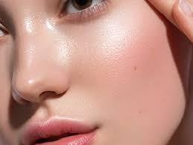 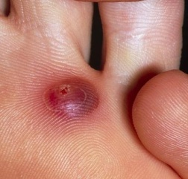

Fig. 1(Healthy Skin) Fig. 2(Blisters)

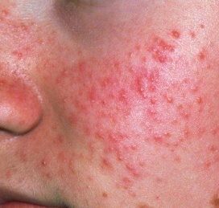 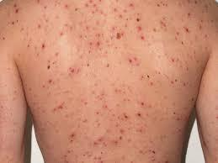

Fig. 3(Acne) Fig. 4(Chickenpox)

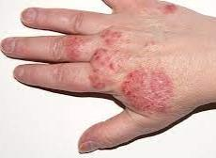 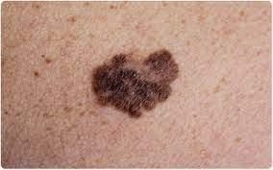

Fig. 5(Eczema) Fig. 6 (Melanoma)

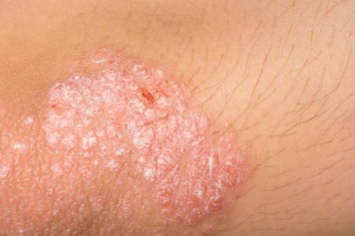

Fig. 7 (Psoriasis)

# **Methodology**

The Smartphone application is developed in a flutter framework with Google TensorFlow. We used a teachable machine (Web-based GUI) to train our model through various images.

## Software Requirements

* Flutter Framework: Flutter is an open-source framework created by Google to provide a multi-cross platform application.



* Vs code: It is an open-source software developed by Microsoft. It helps Programmers code various web, mobile-based applications.



* Teachable Machine: It is a web-based GUI (<https://teachablemachine.withgoogle.com/>) tool for creating machine learning models. It facilitates users to customize the model parameters, data privacy[6].
* Virtual Smartphone Emulator: An Emulator is a software or hardware device that facilitates users to test applications. The host computer can install application on the emulator to test the application or to use it.

## Data collection

The Data Collect in form of images is from different sources over the internet. The Data Contain images of seven different skin condition. Each of which is fed into the model.

Detecting Healthy Skin is as equally important as detecting infected skin. Healthy skin images are taken from authors of different peoples

## Model creation

The Model created by the author is created by Google Teachable Machine (Web-based GUI). The Training Epochs were taken as 50, with a batch size of 16 and a learning rate of 0.001.

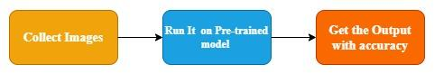

Fig. 8 Explain the concept in which our app works.

## App Development

The application developed is coded in a modular fashion. The primary language used for programming the application is dart using the flutter framework.

The application performance is totally dependent upon the goodness of the Model. The application does not require internet or cloud connectivity to work.

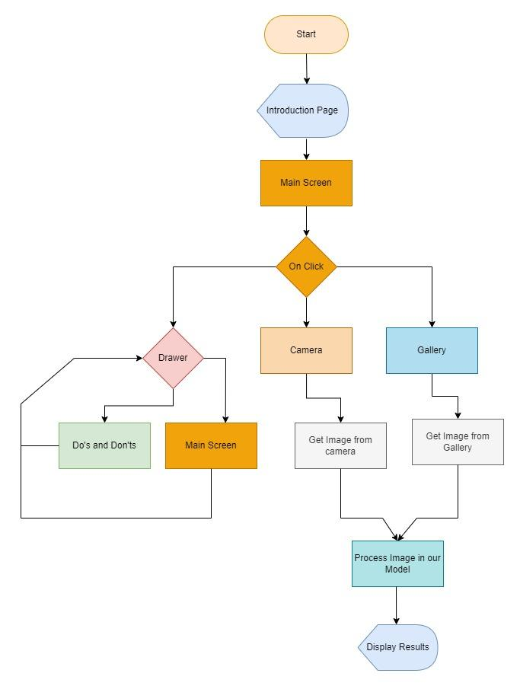

Fig. 9 To explain the System flow diagram of the application

### Navigation

In applications developed, Routes are used to navigate through different screens. On using scaffold with drawer widget. The user can easily able to navigate through different pages. In Fig 9. It can be seen that navigation between Main Screen and the Do’s and Don’t screen is possible with the help of the drawer.

### Model Loading

In Fig 9. The model is loaded into the memory as soon as the user clicks on the camera or the gallery button.

After collecting the image through the camera or gallery which is shown as the collect images in Fig 8. The image is then fed into the model. The model returns the output in the form of a dynamic <list> data type from which the result and accuracy can be obtained.

# **Result and Discussion**

Skin disease can be deadly proper care and detection of disease is needed within a time period. In this, paper an application is proposed to detect the particular disease from which the person is suffering.

The Model give an average accuracy of 77% to 87%.

# **Conclusion and Future Work**

Our future work includes making a robust system to make the user contact doctors easily with the help of social media.

For user’s with poor economical backgrounds to get proper cure. An option like sponsoring and a free check-up are provided within a period of time.

##### **References**

[1] B. Barankin and J. DeKoven, “Psychosocial effect of common skin diseases,” *Can. Fam. Physician*, vol. 48, no. APRIL., pp. 712–716, 2002.

[2] V. R. Balaji, S. T. Suganthi, R. Rajadevi, V. Krishna Kumar, B. Saravana Balaji, and S. Pandiyan, “Skin disease detection and segmentation using dynamic graph cut algorithm and classification through Naive Bayes classifier,” *Meas. J. Int. Meas. Confed.*, vol. 163, p. 107922, 2020, doi: 10.1016/j.measurement.2020.107922.

[3] N. Hameed, A. M. Shabut, M. K. Ghosh, and M. A. Hossain, “Multi-class multi-level classification algorithm for skin lesions classification using machine learning techniques,” *Expert Syst. Appl.*, vol. 141, pp. 1–33, 2020, doi: 10.1016/j.eswa.2019.112961.

[4] N. Hameed, A. Shabut, and M. A. Hossain, “A Computer-Aided diagnosis system for classifying prominent skin lesions using machine learning,” *2018 10th Comput. Sci. Electron. Eng. Conf. CEEC 2018 - Proc.*, pp. 186–191, 2019, doi: 10.1109/CEEC.2018.8674183.

[5] N. Alamdari, K. Tavakolian, M. Alhashim, and R. Fazel-Rezai, “Detection and classification of acne lesions in acne patients: A mobile application,” *IEEE Int. Conf. Electro Inf. Technol.*, vol. 2016-Augus, pp. 739–743, 2016, doi: 10.1109/EIT.2016.7535331.

[6] M. Carney *et al.*, “Teachable machine: Approachable web-based tool for exploring machine learning classification,” *Conf. Hum. Factors Comput. Syst. - Proc.*, 2020, doi: 10.1145/3334480.3382839.

[7] K. Polat and K. Onur Koc, “Detection of Skin Diseases from Dermoscopy Image Using the combination of Convolutional Neural Network and One-versus-All,” *J. Artif. Intell. Syst.*, vol. 2, no. 1, pp. 80–97, 2020, doi: 10.33969/ais.2020.21006.